Auckland White Pages Freelister Upgrade Promo eDM Workflow
Target Audience
- Auckland White pages section free listing customers with no paid presence in Auckland Yellow book.

Offer
- Upgrade to 2 x chargeable listings for $11 per month. Total price 18 x $11 = $198.
- Upgrade to Bold Name & 2 x chargeable listings for $14.95 per month. Total price 18 x $14.95 = 269.10.

eDM
- Deployed Friday September 1, 2023. Offer ends on 5pm Tuesday 31 October 2023.
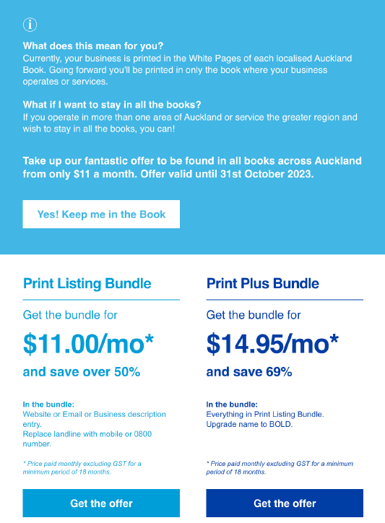

Workflow
CTA clicked: Click on CTA in email -> go to landing page -> Complete form -> form submission creates a ticket in Business Support pipeline. Titled “Auckland White pages Free Listing Print Plus Bundle $14.95 per month request” or “Auckland White pages Free Listing Print Bundle $11 per month request”.

- Customer request offer:
- Business Support contacts customer confirms upgrade, content and final pricing.
- If customer isn’t in Hubspot, then set up customer and associate the Deal to customer account.
- Deal value either $198 or $269.10 based on offer taken up.
- BAU E+ process, billing term to be monthly (18)
- E+ Discount Code: Use manual Rate MBST “Print Boost Offer”, Discount Reason 34 “Freelister upgrade”
  - For Print Listing Bundle, price the two Chargeable items at $99 each.
  - For the Print Listing Plus Bundle, price the two chargeable items at $72 each and bold name black at $125.10.

- Freelister Promo Upgrade Business Rules / Exclusions:
  - Does not replace paid White pages content. Freelisters only.
  - Upgrade is to standard listing entry in Auckland White pages (Name, Address, Landline)

